Increasing Motor Length

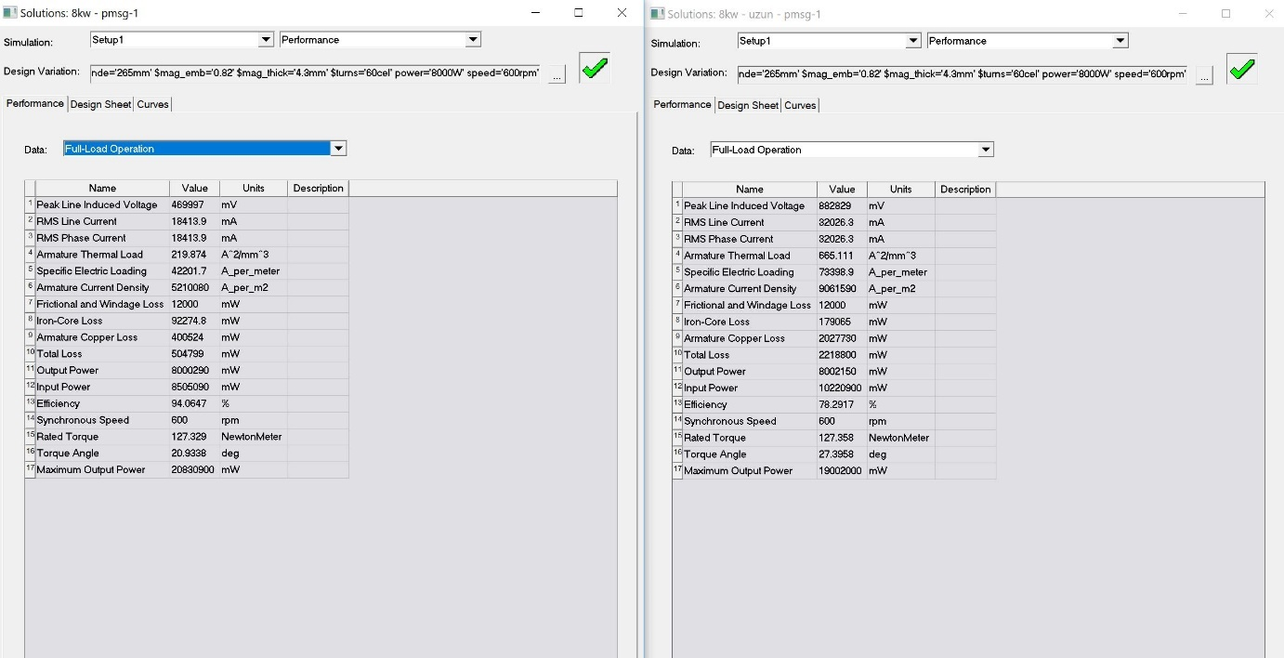

Şekil : Full-load

Induced voltage, line current, thermal load, loss(total) increase and efficiency decrease.

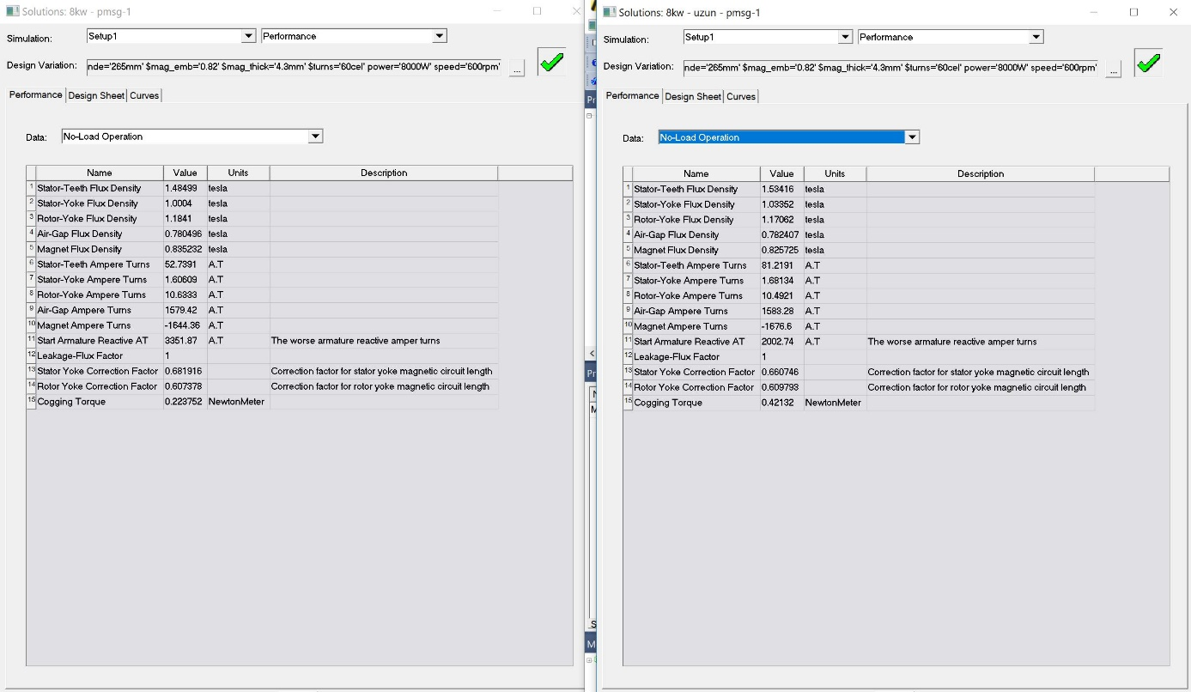

Şekil : No-load

Cogging torque, stator teeth flux density increase.

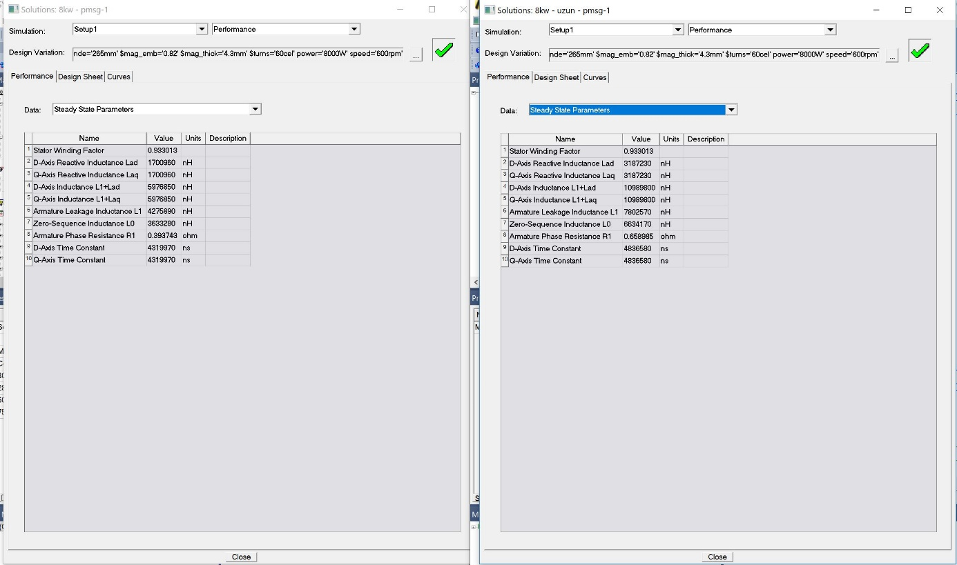

Şekil :Seady-State

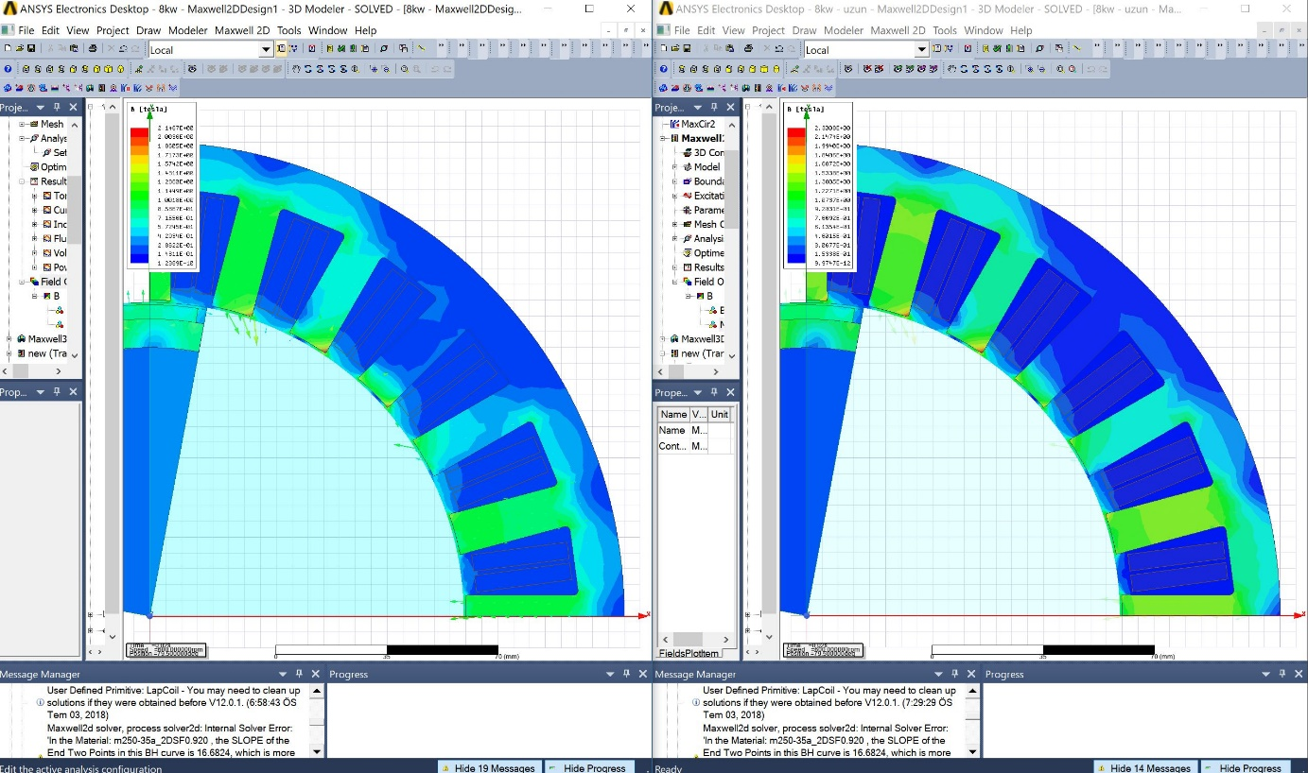

Şekil : B-Field

Increasing Diameter

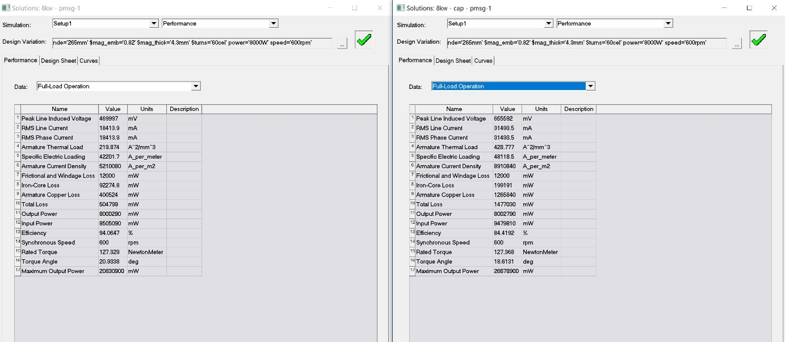

Şekil : Full-load

Induced voltage, line current, thermal load, loss(total) increase and efficiency decrease.

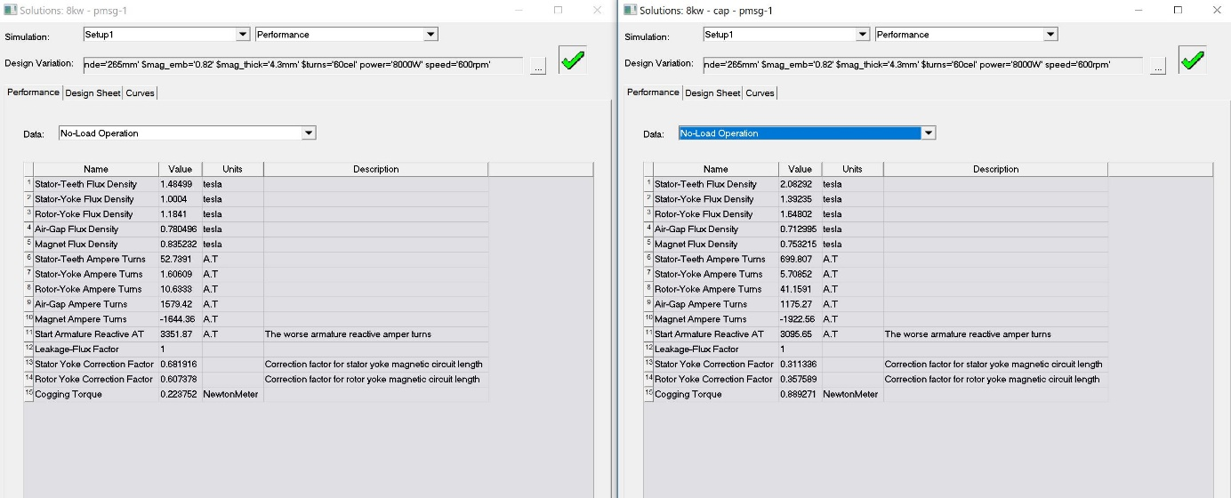

Şekil : No-load

Cogging torque, stator teeth flux density(exceeds the boundary) increase, air-gap flux density decrease.

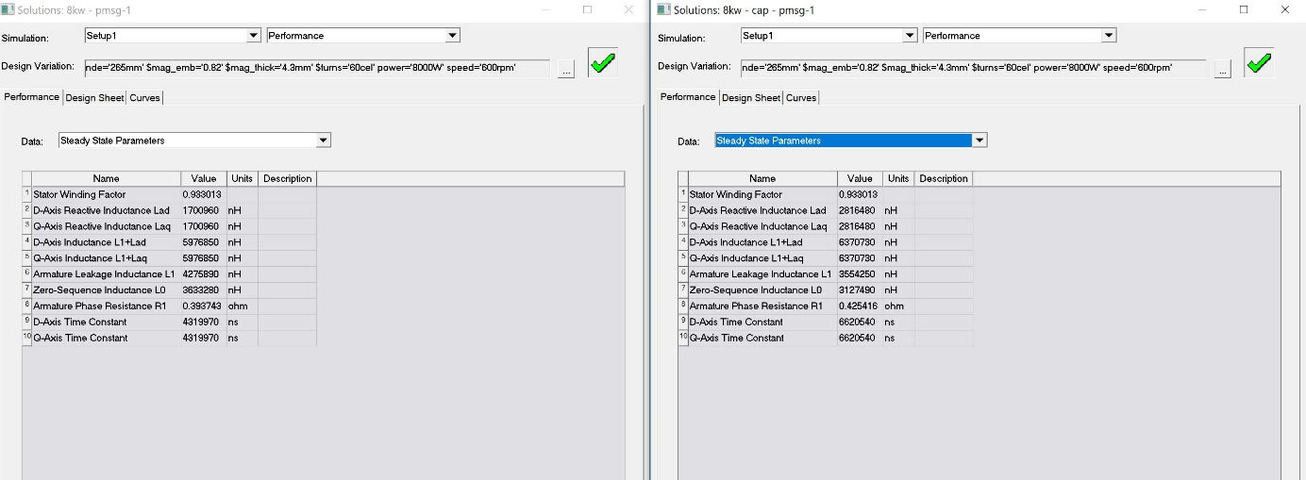

Şekil : Steady-state

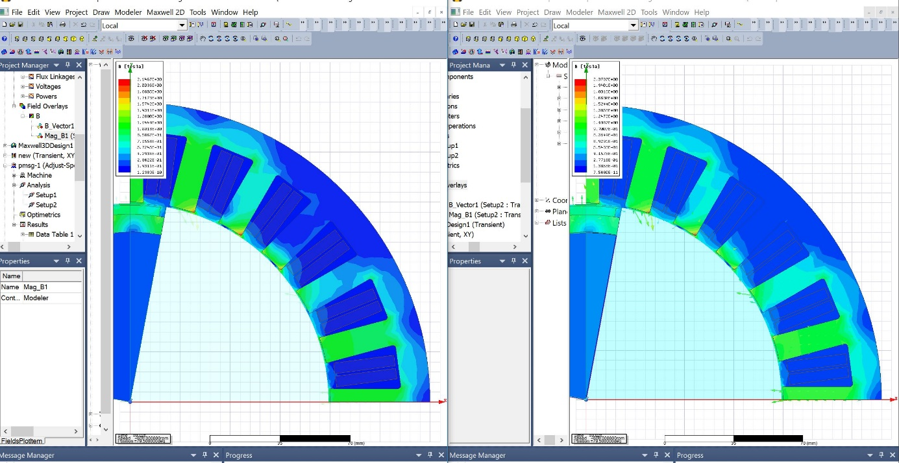

Şekil : B-Field

Increasing Air-gap

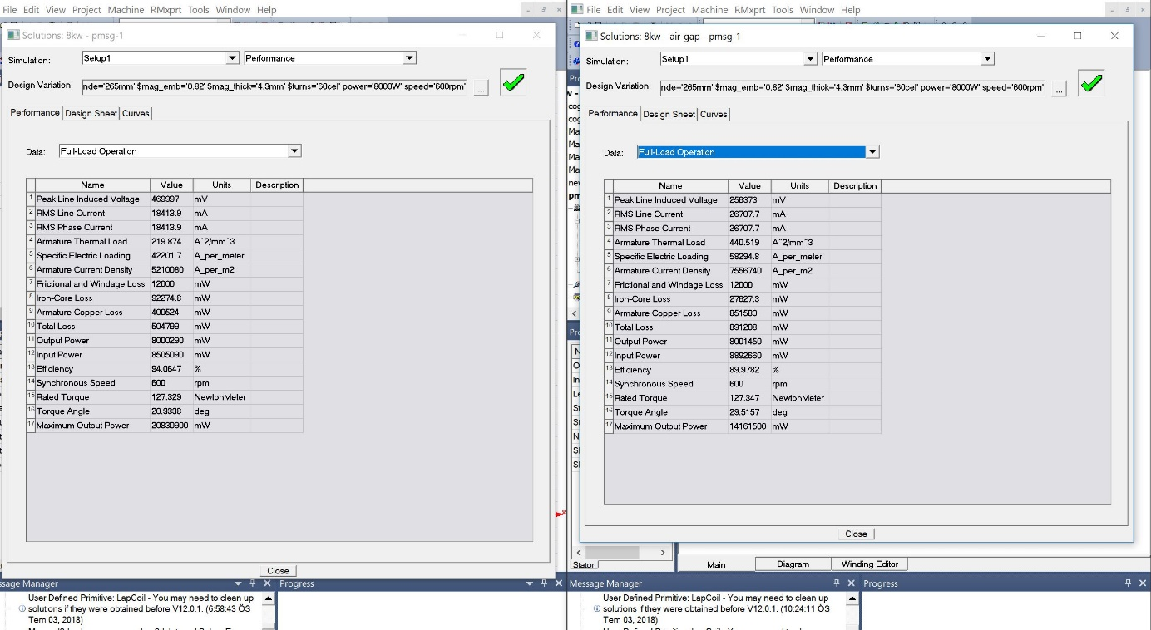

Şekil : Full-load

Line current, thermal load, loss(total) increase and efficiency,induced voltage decrease.

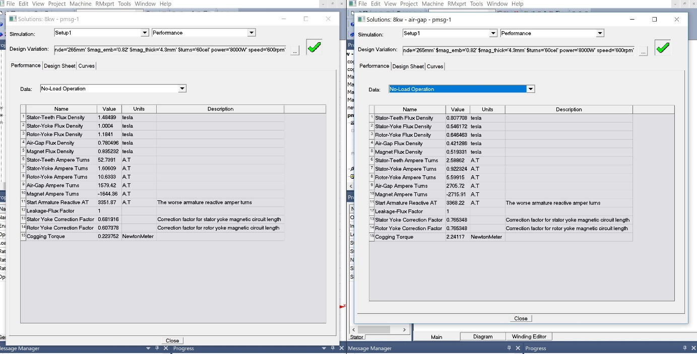

Şekil :No-load

Cogging torque increase and air-gap flux density,stator-teeth flux density decrease.

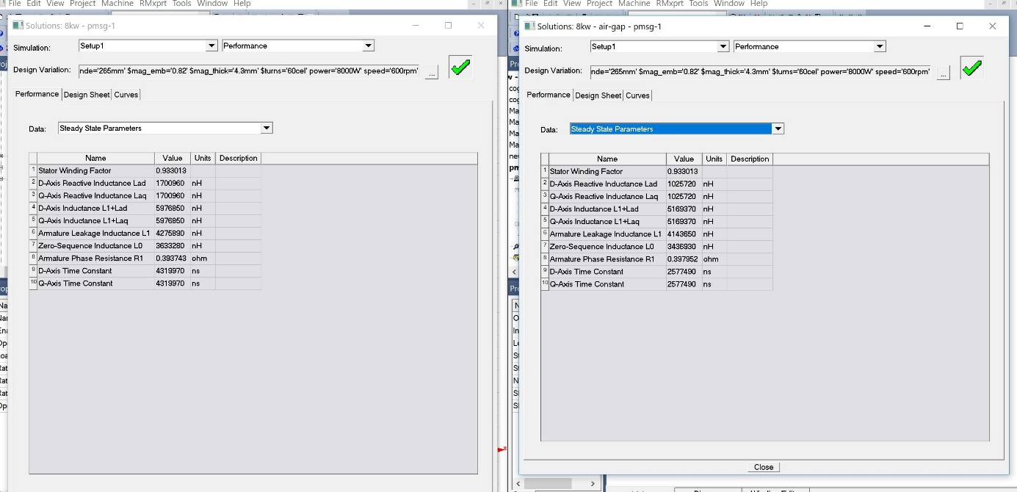

Şekil : Steady state

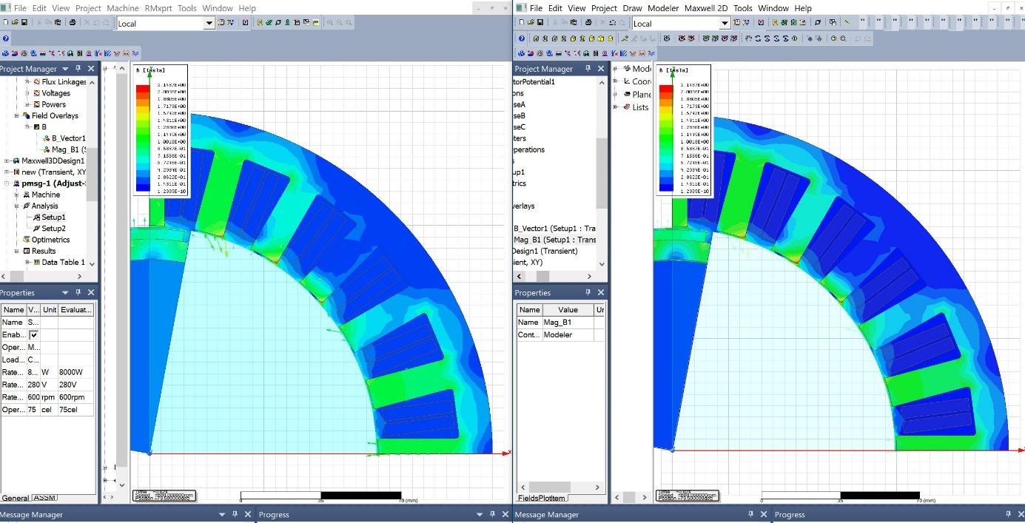

Şekil : B-Field

Increasing tooth thickness

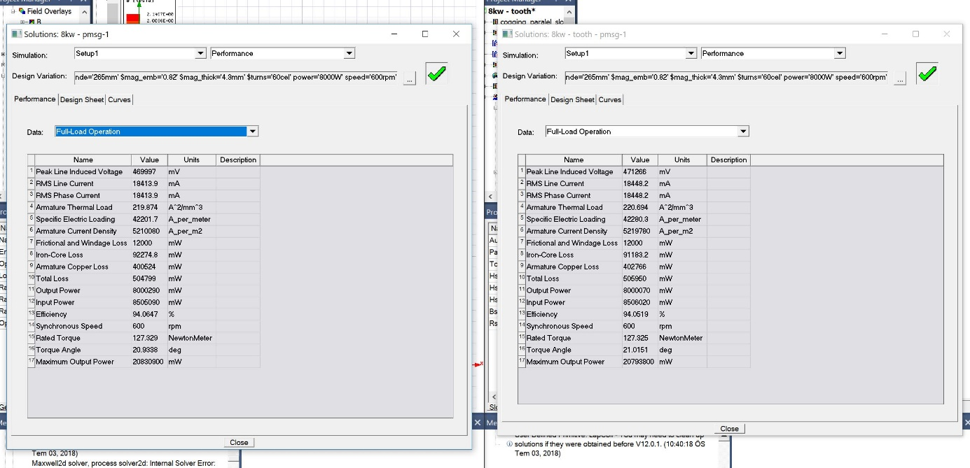

Şekil :Full-load

Induced voltage, line current, thermal load, loss(total) increase and efficiency decrease.(however, changes are very small)

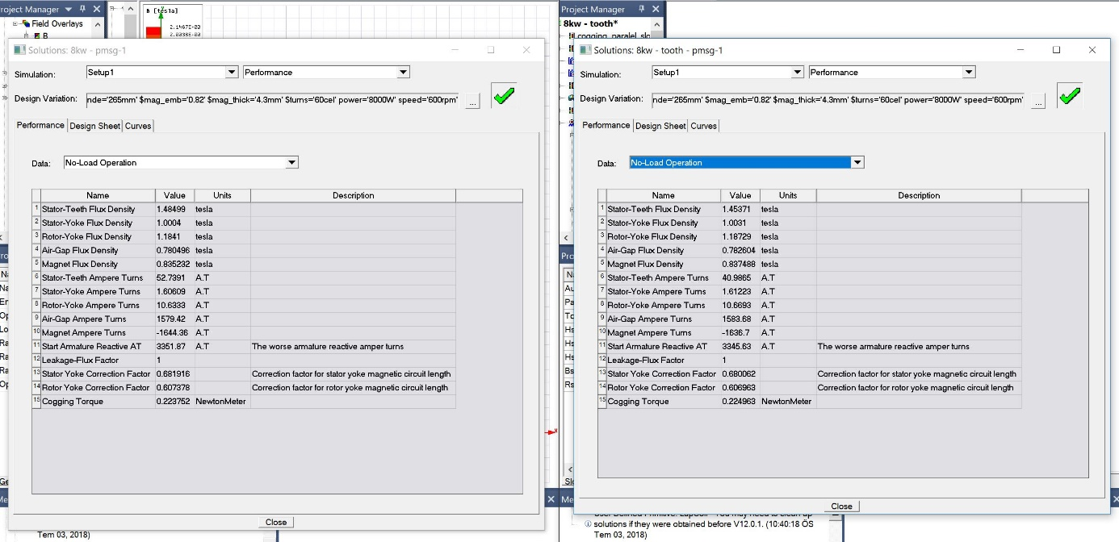

Şekil : No-load

Cogging torque, air-gap flux density increase and stator-teeth flux density decrease.

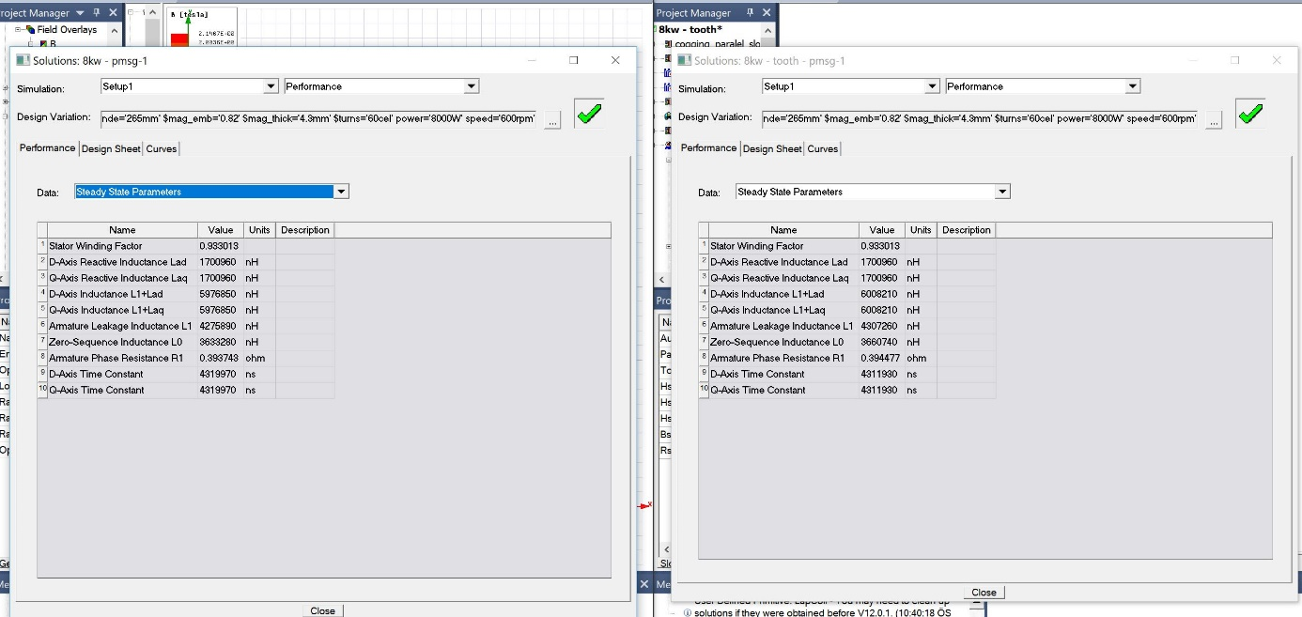

Şekil : Steady-state

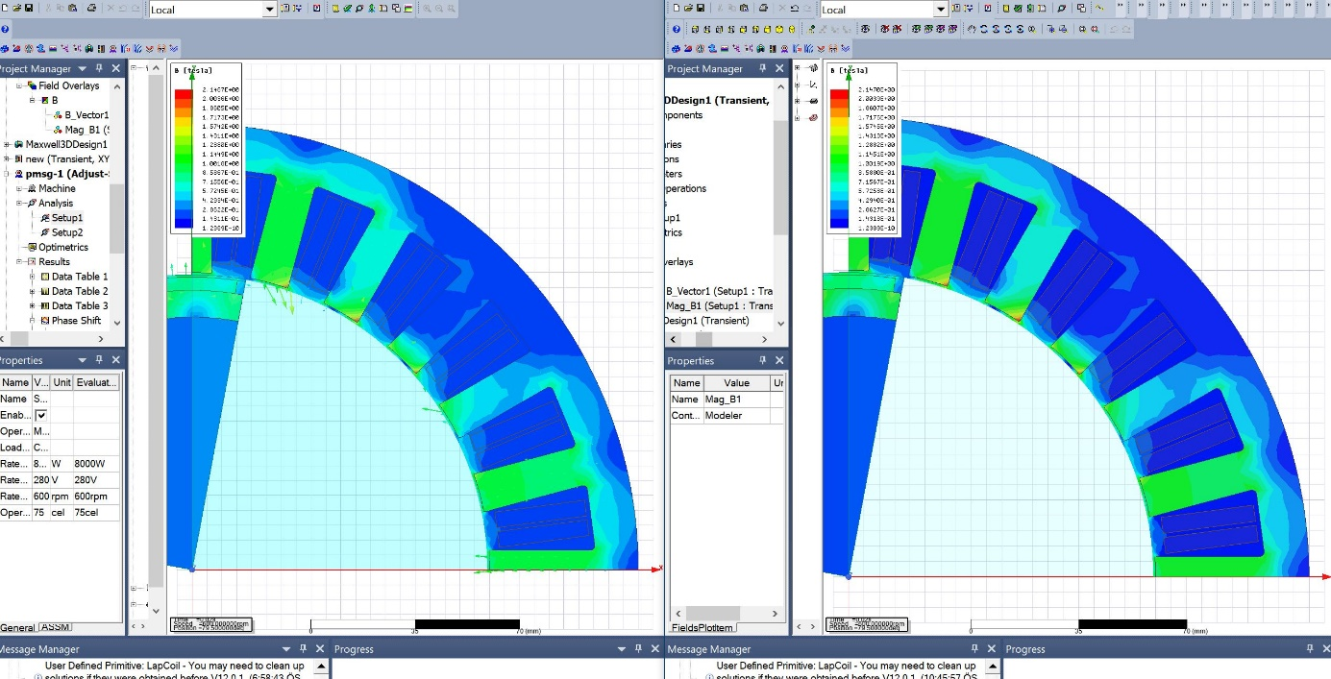

Şekil : B-Field

Number of conductors increase

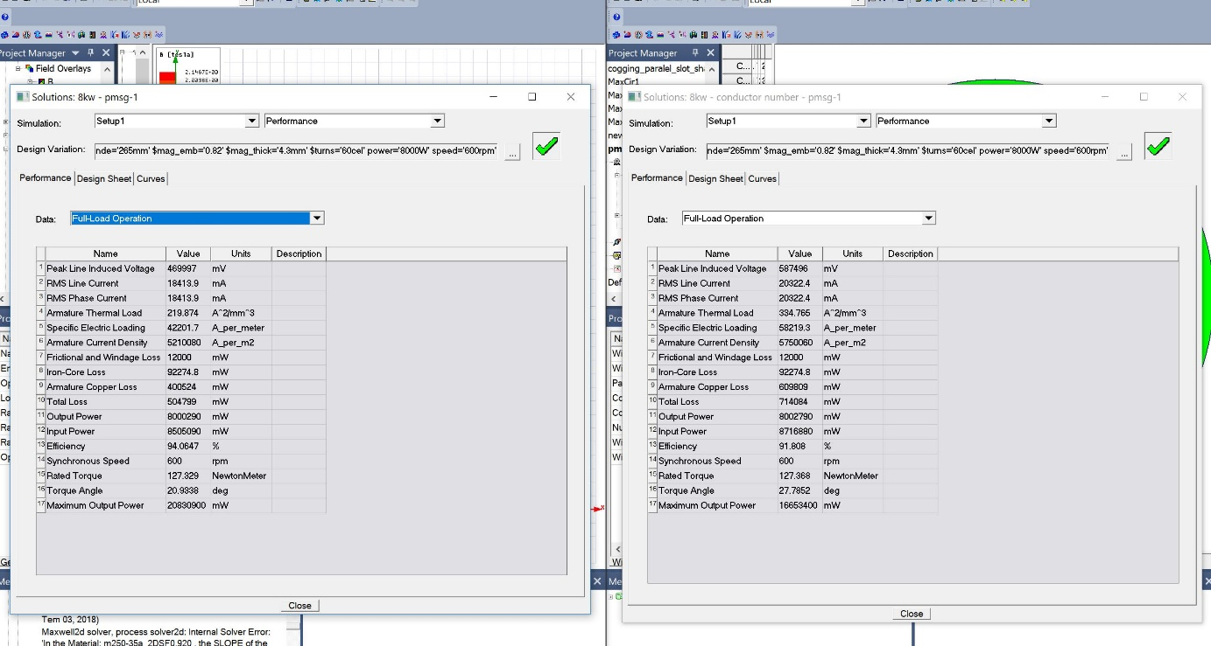

Şekil : Full-load

Induced voltage, line current, thermal load, loss(total) increase and efficiency decrease.

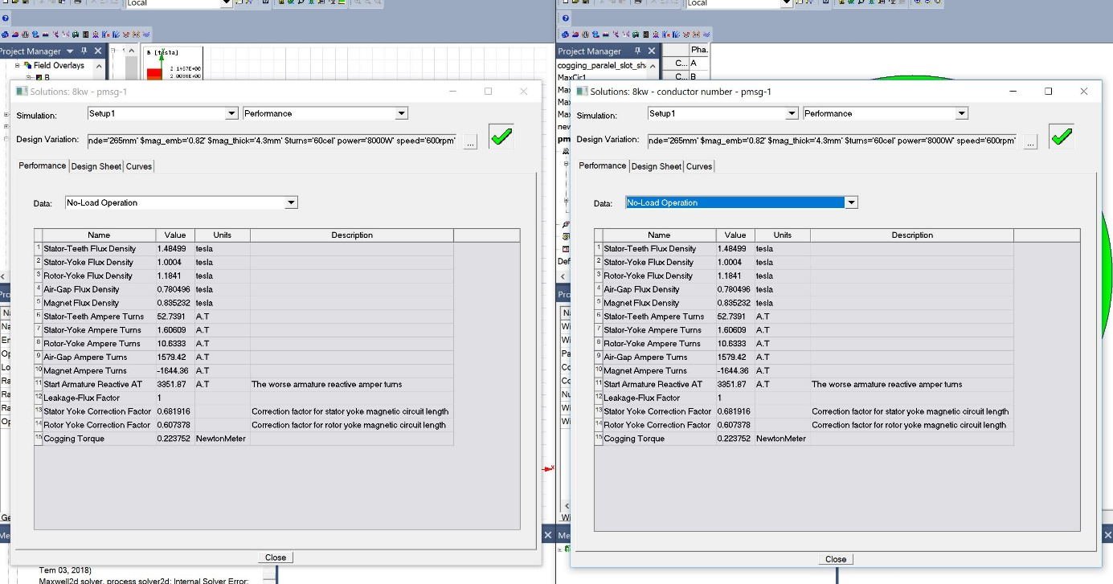

Şekil : No-load

Cogging torque, stator teeth flux density stay same.

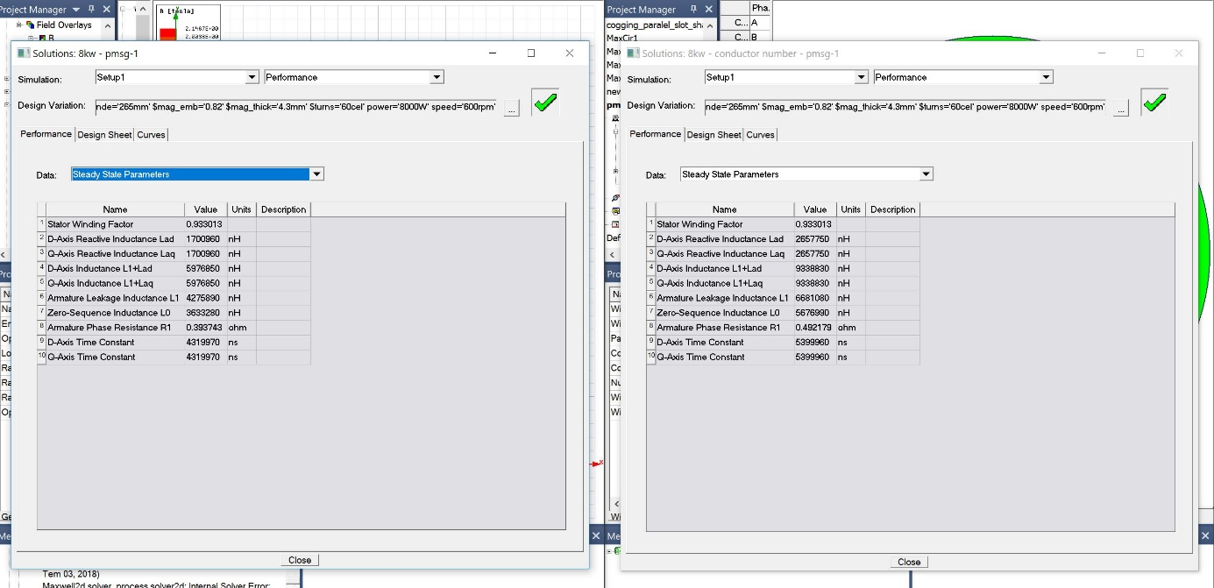

Şekil : Steady-state

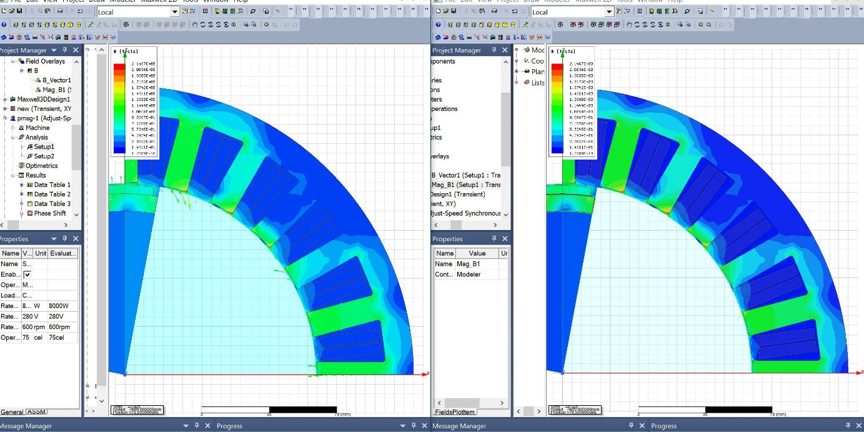

Şekil : B-Field

Changing magnet (increasing permeability)

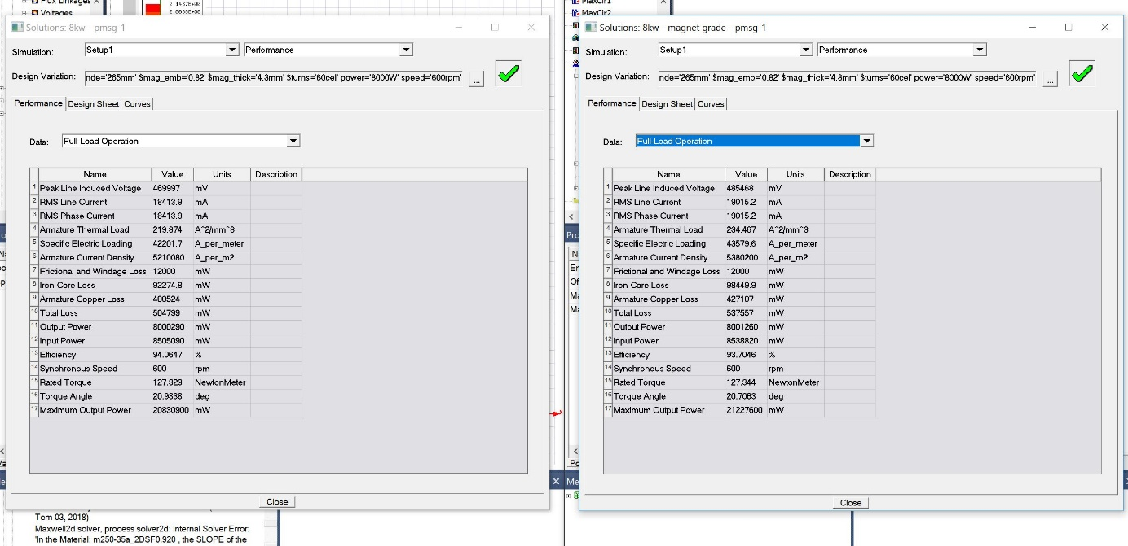

Şekil : Full-load

Induced voltage, line current, thermal load, loss(total) increase and efficiency decrease.

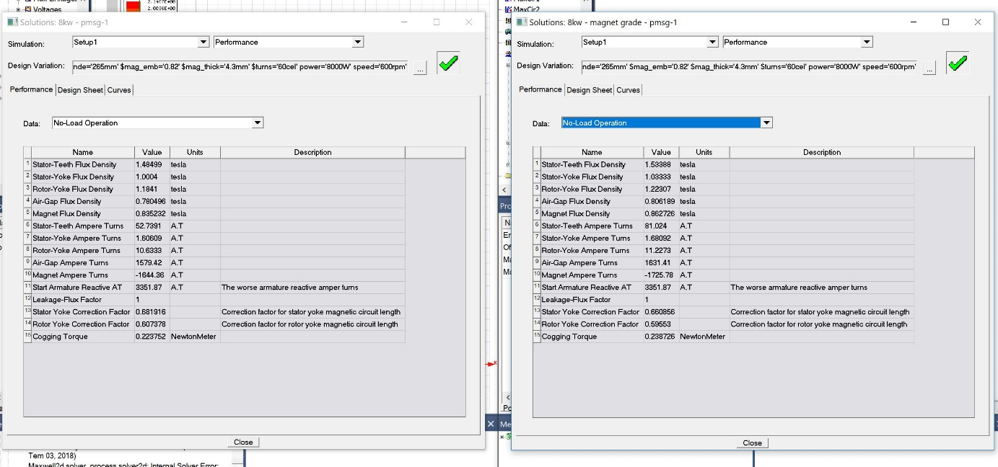

Şekil : No-load

Cogging torque, stator teeth flux density increase.

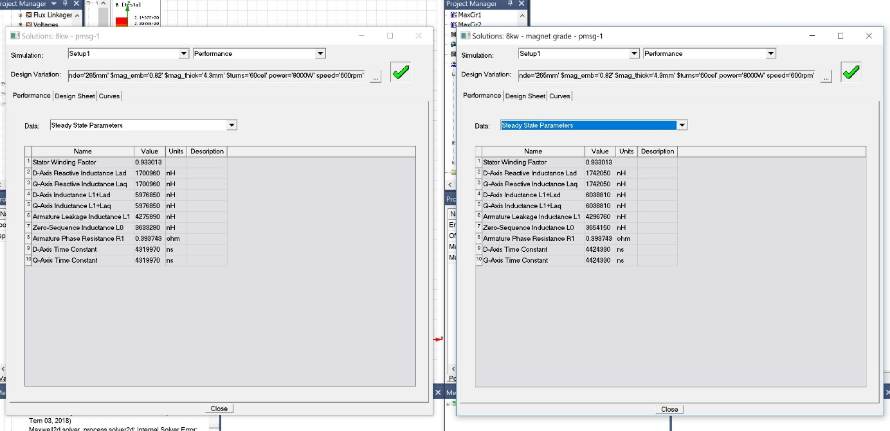

Şekil : Steady-state

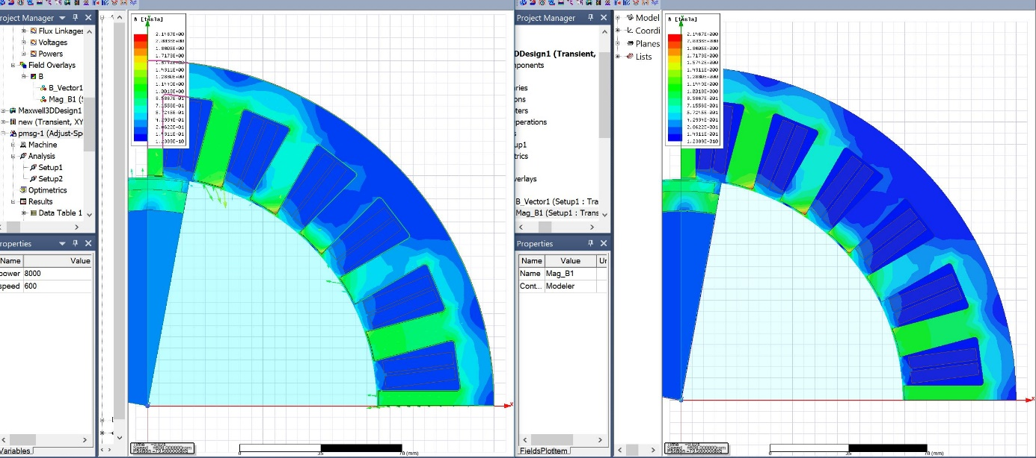

Şekil : B-Field

EMB increasing

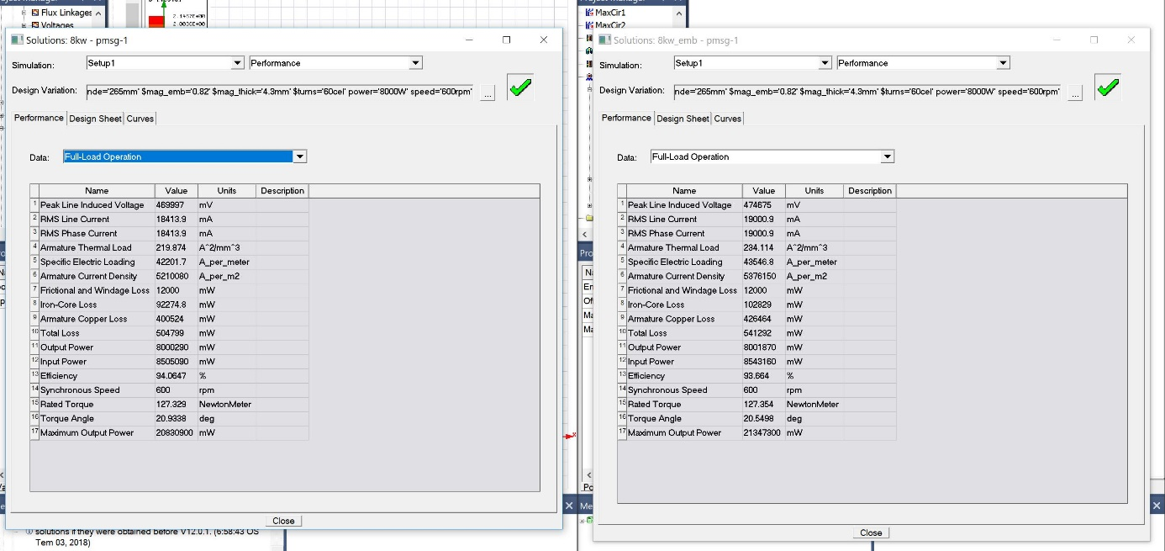

Şekil : Full-load

Induced voltage, line current, thermal load, loss(total) increase and efficiency decrease.

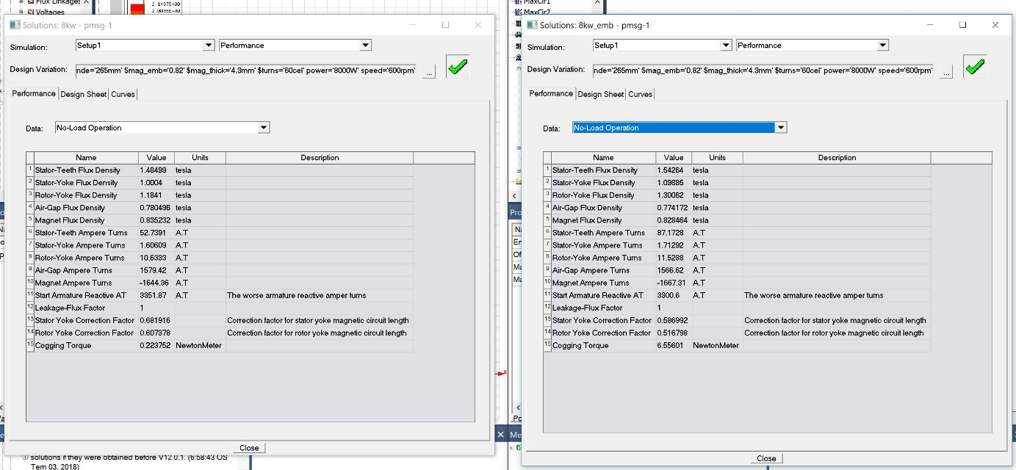

Şekil : No-load

Cogging torque(amazing increase), stator teeth flux density increase.

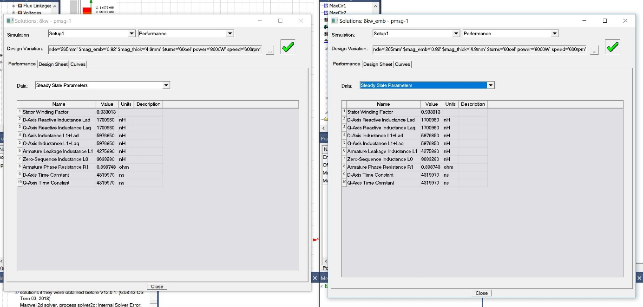

Şekil : Steady-state

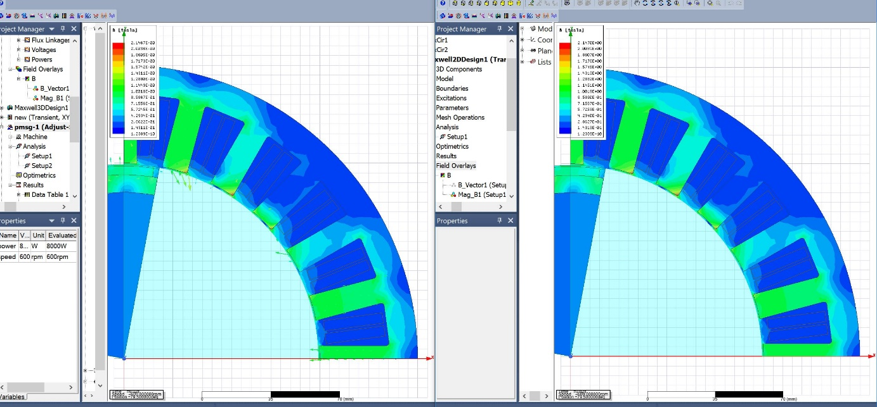

Şekil : B-Field